Solar Panel and Battery Kit

Installation Guide

May 2019

# Packing List

Item 1:

Solar Panel

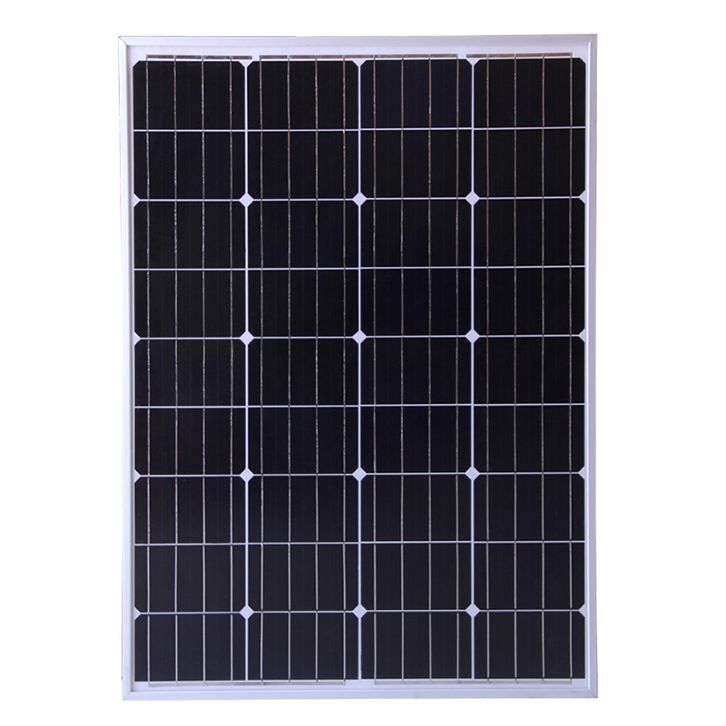

Item 2:

Lithium Battery Pack

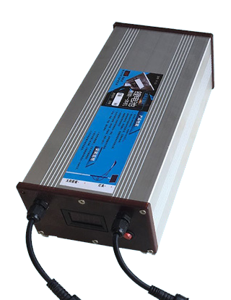

Item 3:

Mounting Kit

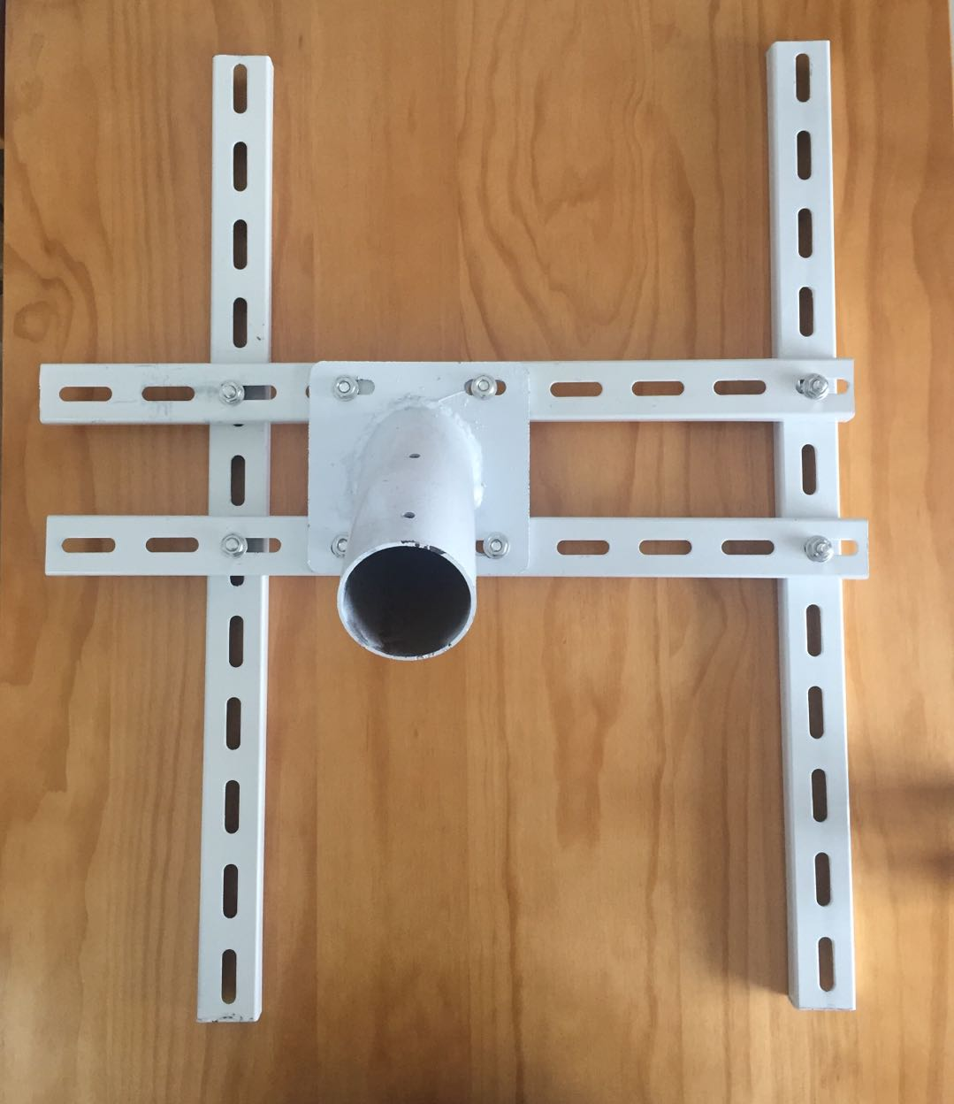

# Specifications

1. Solar Panel

Electrical Characteristics

|  |  |
| --- | --- |
| Maximum Power Pmax | 80W |
| Voltage at Pmax(Vmp) | 18V |
| Current at Pmax(Imp) | 2.2-5.5А |
| Open Circuit Voltage (Voc) | 21.6V |
| Short Circuit Current (Isc) | 2.3-6.5A |
| Maximum Series Fuse | 15A |
| Maximum System Voltage | 700V DC |

Dimensions: 665*815mm

1. Lithium Battery

Electrical Characteristics

|  |  |
| --- | --- |
| Nominal Output Voltage | 12.6V |
| Nominal Output Current | 2A |
| Capacity | 50Ah |
| Charge Voltage | 18V |

Operational Temperature: −20⁰C to 60⁰C

Dimensions: 140*90*350mm

# 

# Installation procedure

Step 1:

Install the bolts in the holes, which are circled in red inFigure 1. Tighten the nuts and make sure that the rails that make up the base are holding tight against each other.

This will make an “H” spahepd base, for the Solar Panel to be mounted on top off. The circular pipe in the middle of the sape is mean to fit over a circular shaped pole, so the whole construction sits on top with the panel facing upwards, on an angle.

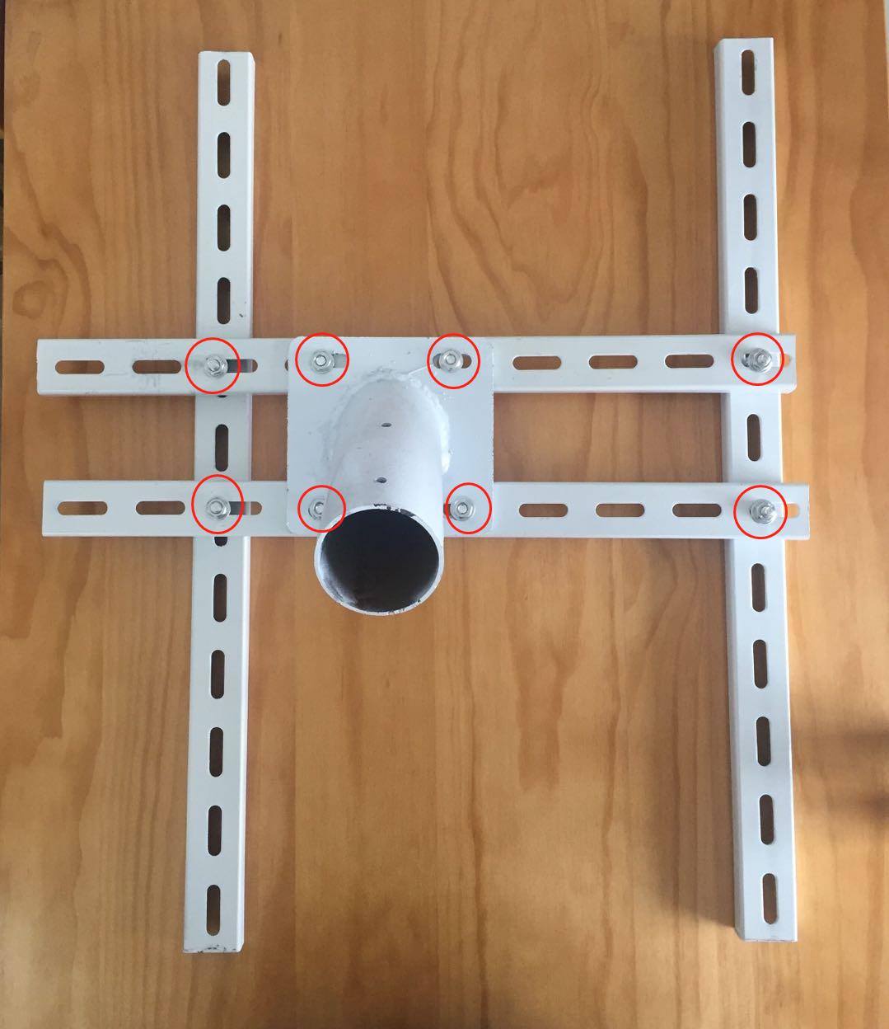

Figure 1

Step 2:

Mount the battery on top of the two paralel rails in the middle. Make sure it is as close as possible to the middle of the construction. Fasten it to the rails with four bolts, each having a washer and a nut. Tighten well, as the battery is quite heavy. Refer to Figure 2 on how to insert the bolts into the railing that is part of the bottom of the baterry casing.

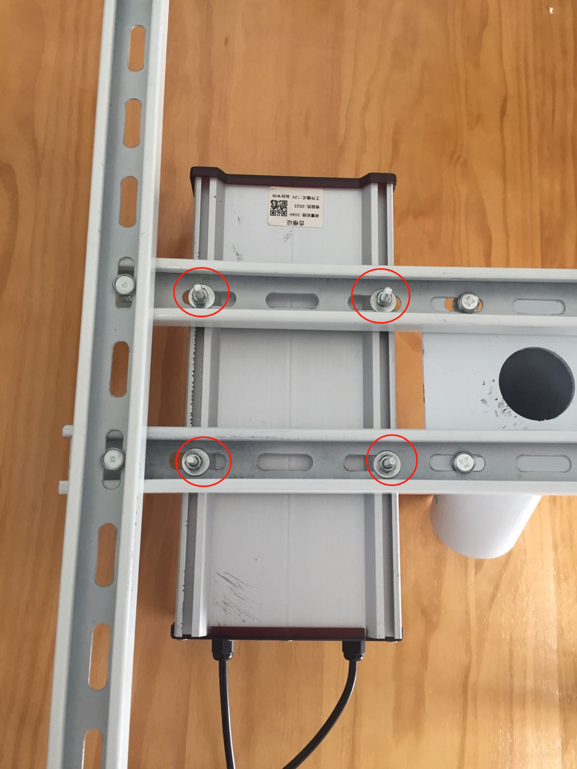

Figure 2

Step 3:

Connect the power cable coming out of the input port of the battery to the screw terminals on the back of the solar panel. Make sure you not to reverse the polarity. Figure 3 shows the connection on the back of the solar panel.

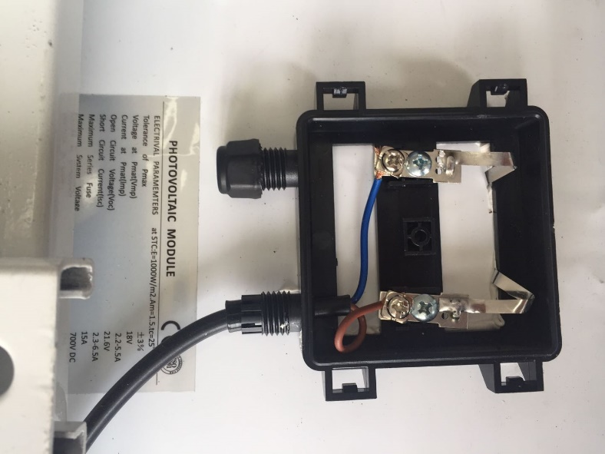

Figure 3

Figure 4 shows where the cable from the solar panel enters the input terminal on the battery.

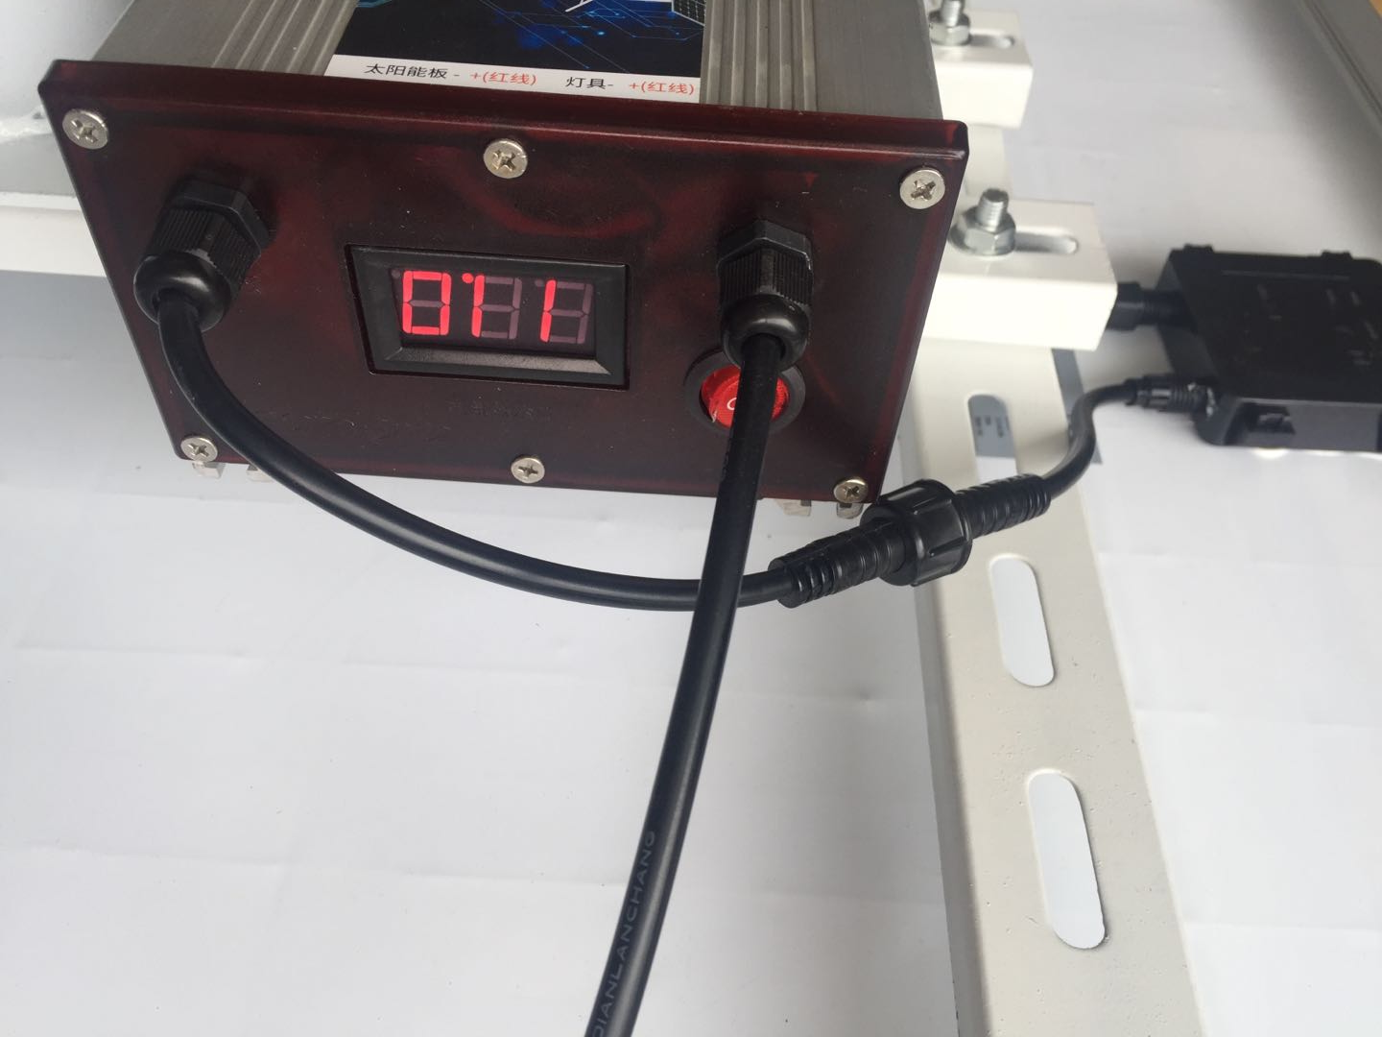

Figure 4

Step 4:

Connect the battery output terminal cable to the power cable coming from the input of the gateway as shown in Figure 5.

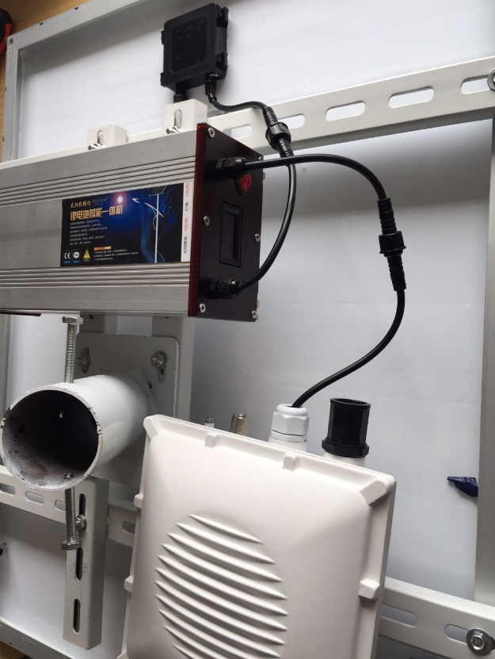

Figure 5

Step 5:

Mount the whole instalation you have assembled so far ot top of a circular pole. Put the panel facing up and insert the pole in the pipe opening on the bottom of the constructiuon. Make sure the pole is of a sufficiently small diameter to fit (65mm recommended). Use two M8 bolts to fasten the ball to the construction as shown in Figure 6.

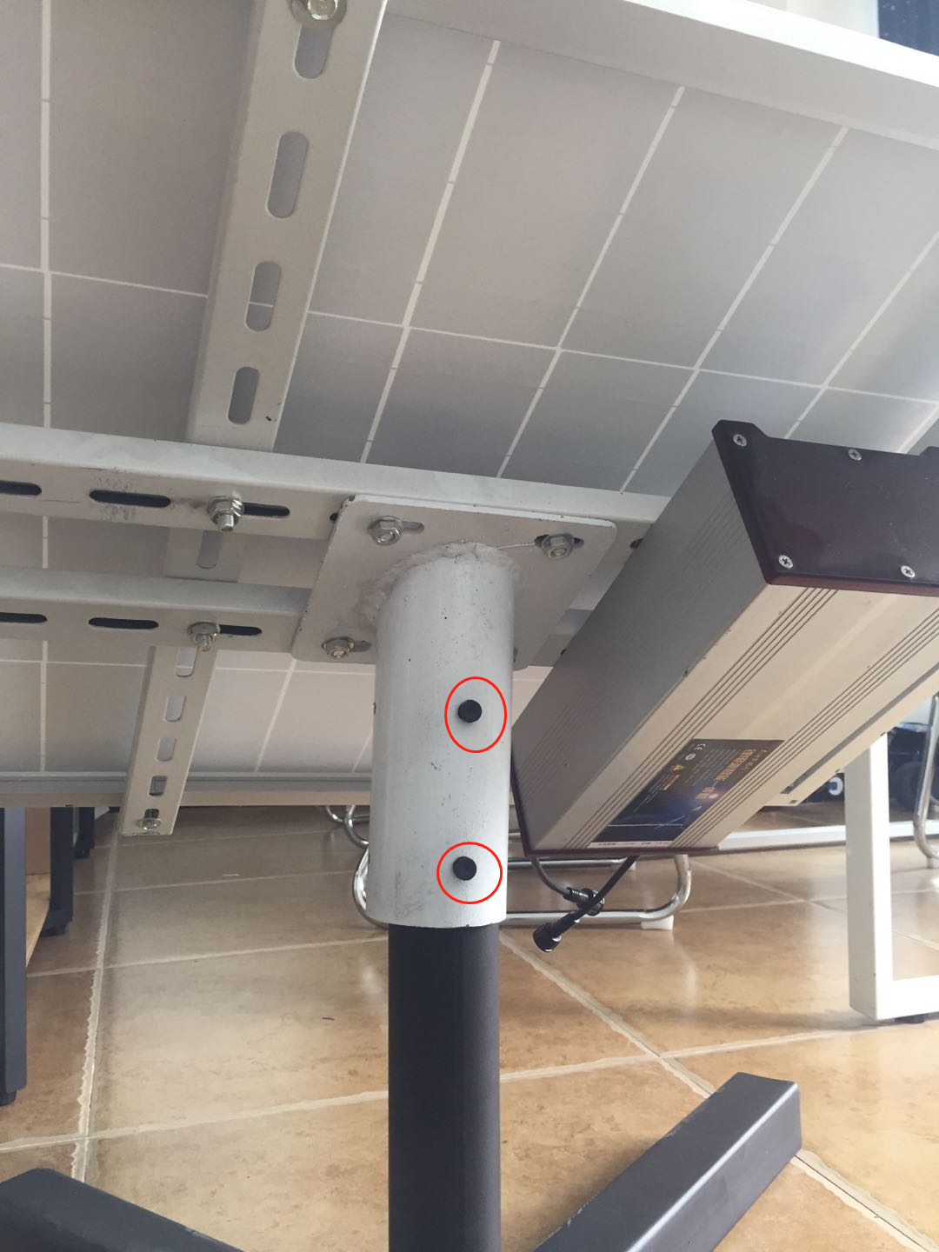

Figure 6

# Caution:

Reversing the polarity when connecting the battery is dangerous and may cause fire. Make sure you the power cord has been connected with the correct polarity.

Your battery mileage will vary depending on local illumination intensity. For a 50Ah battery and a 80W solar panel, such as the ones used in the kit the RAK7249 should function for about 4 days. This is the worst case scenario where there is constant heavy rain and/or constant presense of clowds. If you live in extreme conditions that result in operational time significantly less than 4 days you mighty think of increasing the battery capacity and installing a solar panel with greater power output.

|  |  |  |  |  |  |
| --- | --- | --- | --- | --- | --- |
| C:\Users\weining.gan\AppData\Local\Microsoft\Windows\INetCache\Content.Word\337451579902284365.png | | Rakwireless Public Release | | |  |
| Prepared (also subject responsible if other) | | No. | | | |
| Terry | |  | | | |
| Approved | Checked | Date | Rev | Reference | |
| Zenglei Zhao |  | 2019-05-17 | V1.0 |  | |